**LOGO :**



**LOGIN & SIGNIN :**

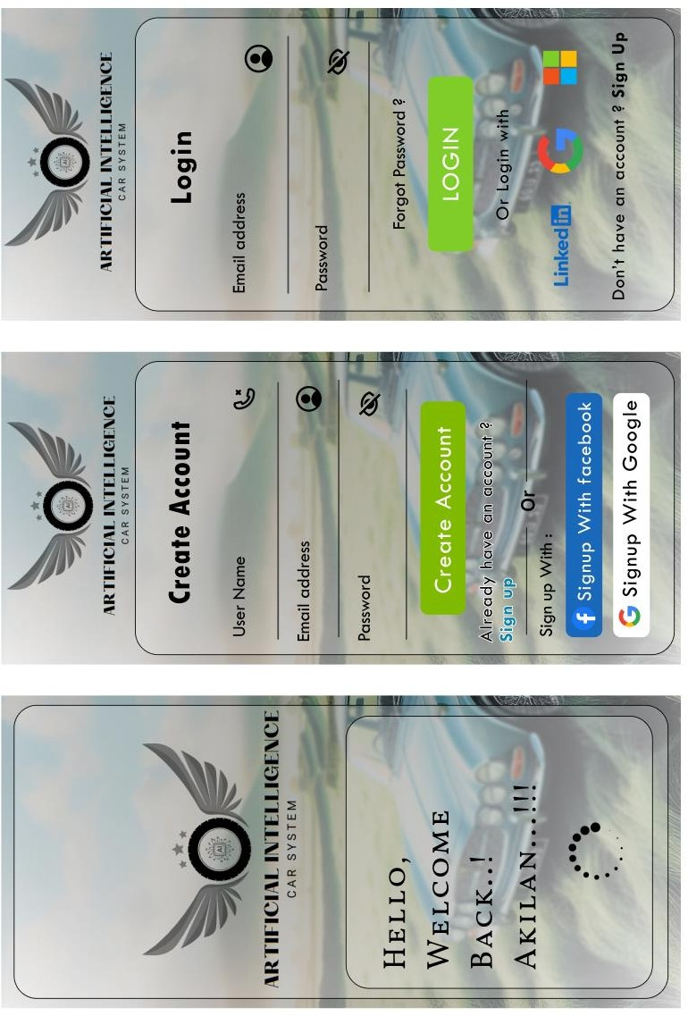

**Empathy Mapping :**

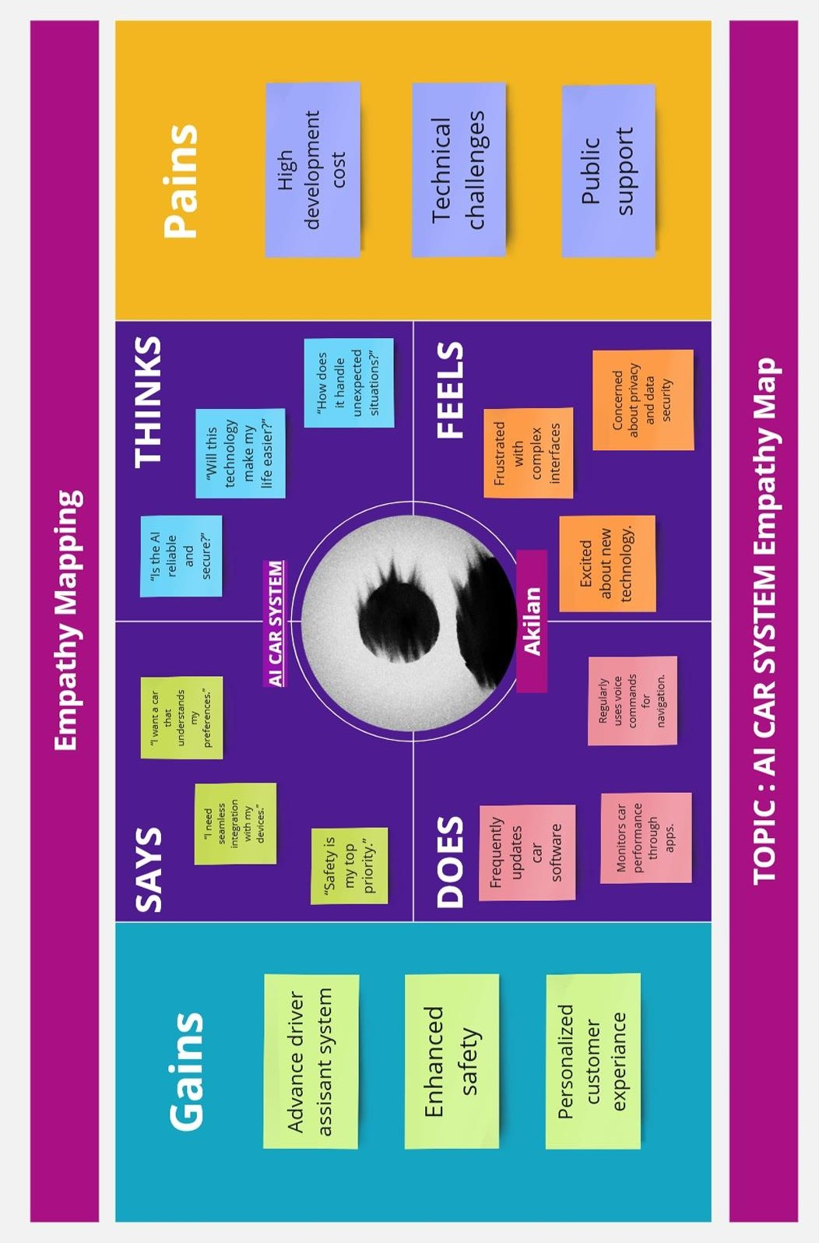

**Empathy Mapping :**

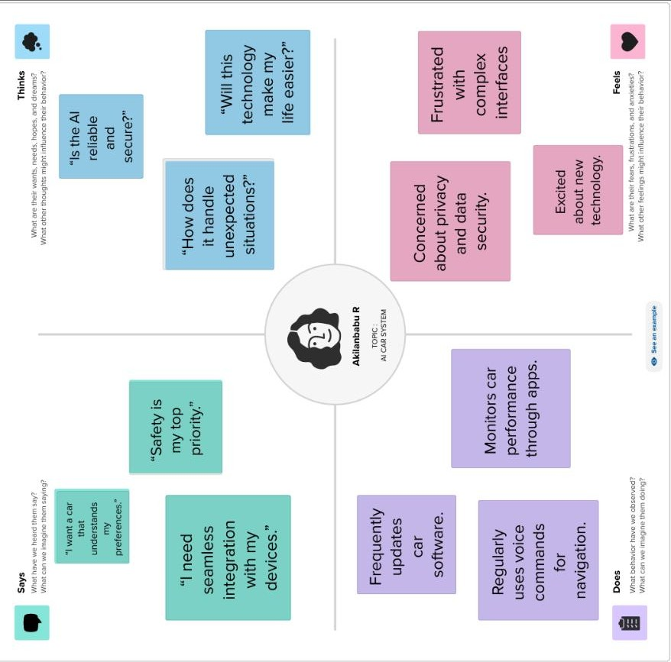

**Journey Map :**

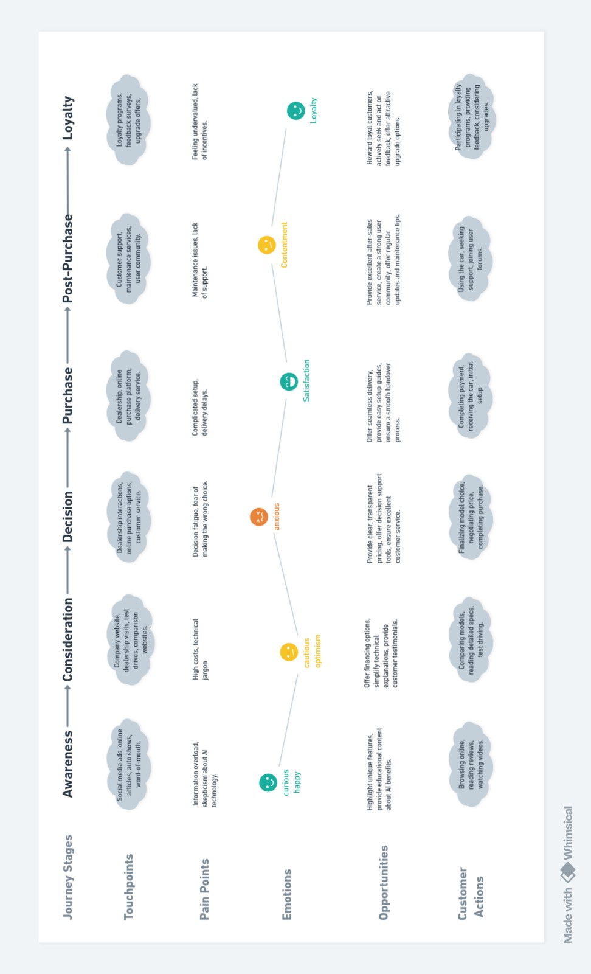

**Journey Map :**

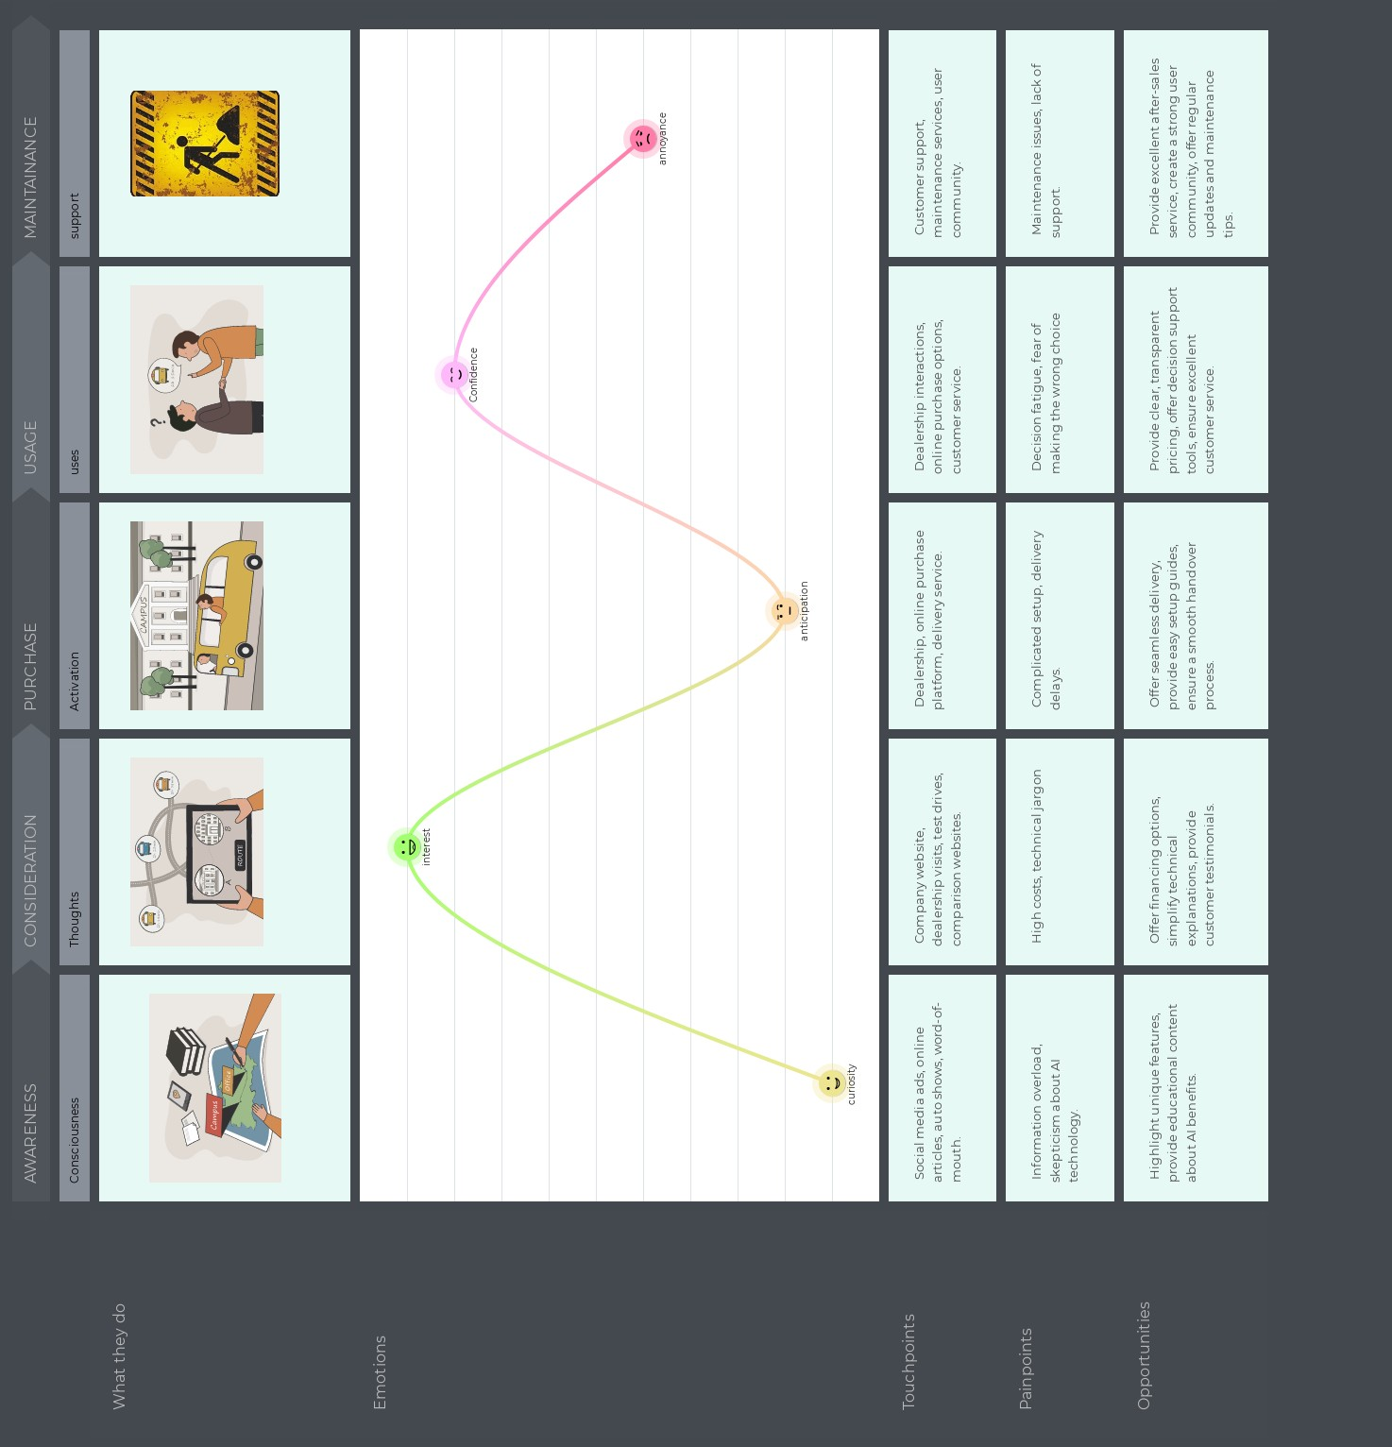

**User Persona:**

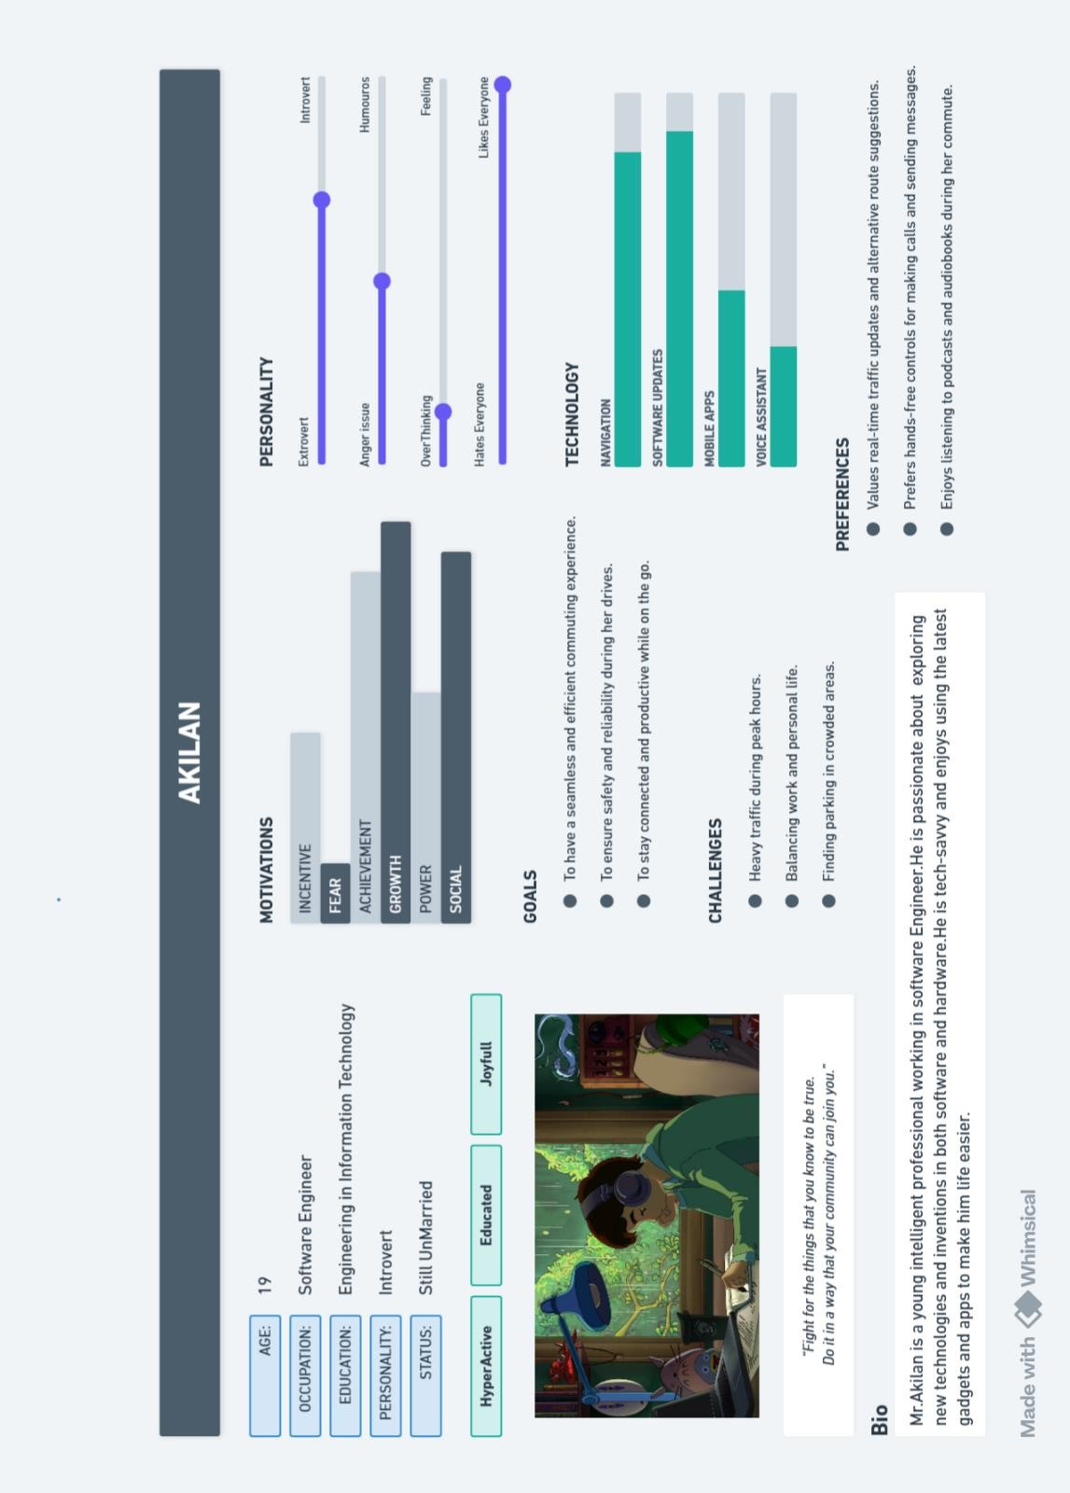

**Ui Patterns :**

WALK THROUGH



REGISTERATION

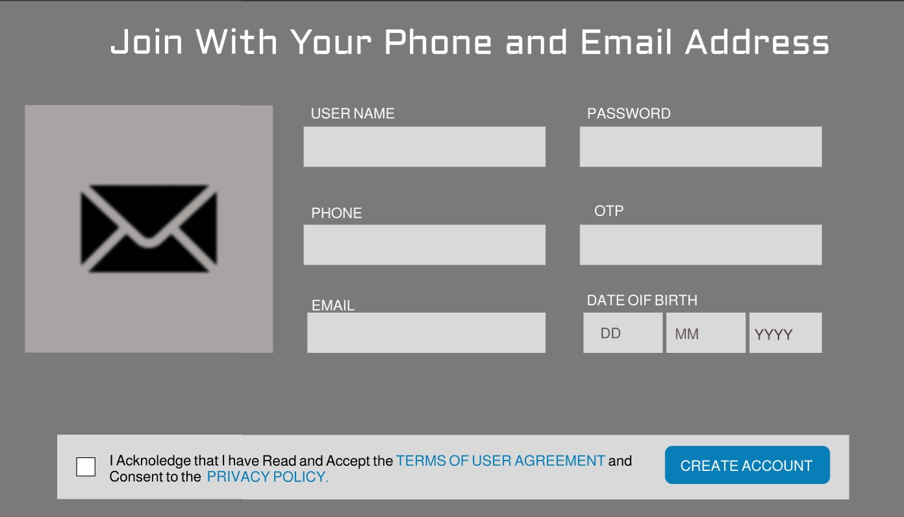

HOME LINK

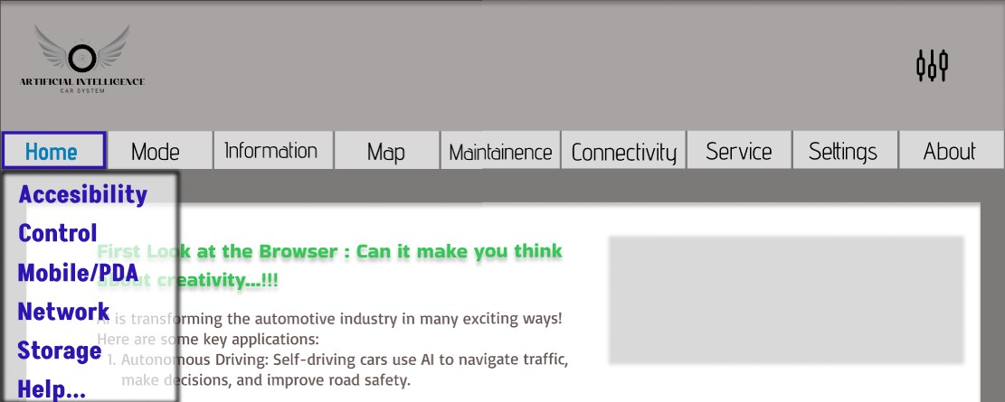

BREAD CRUMBS

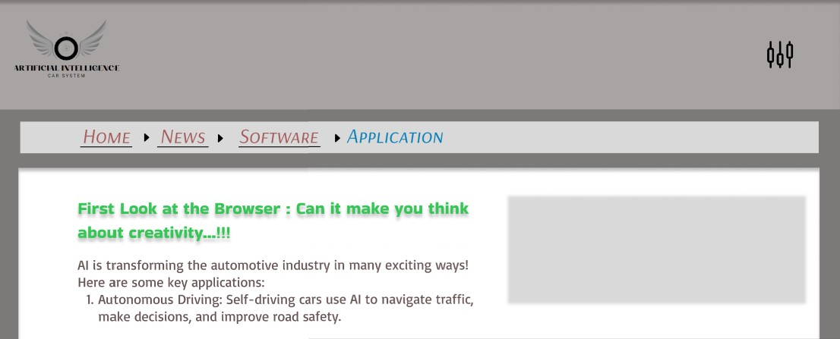

STEPS LEFT

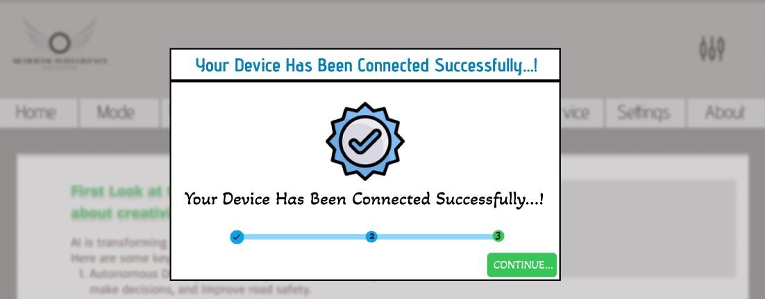

CAPTCHA

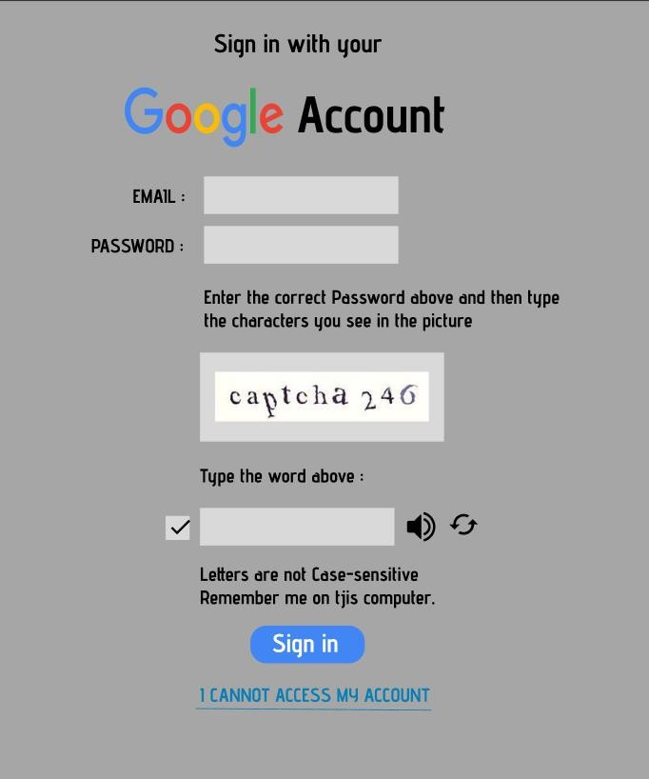

**User Flow :**

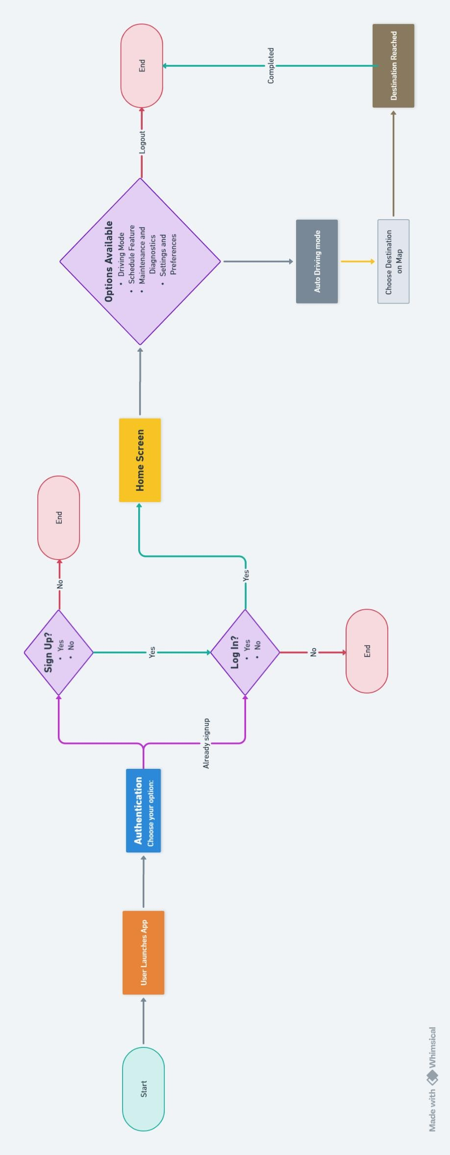

**Online Survey :**

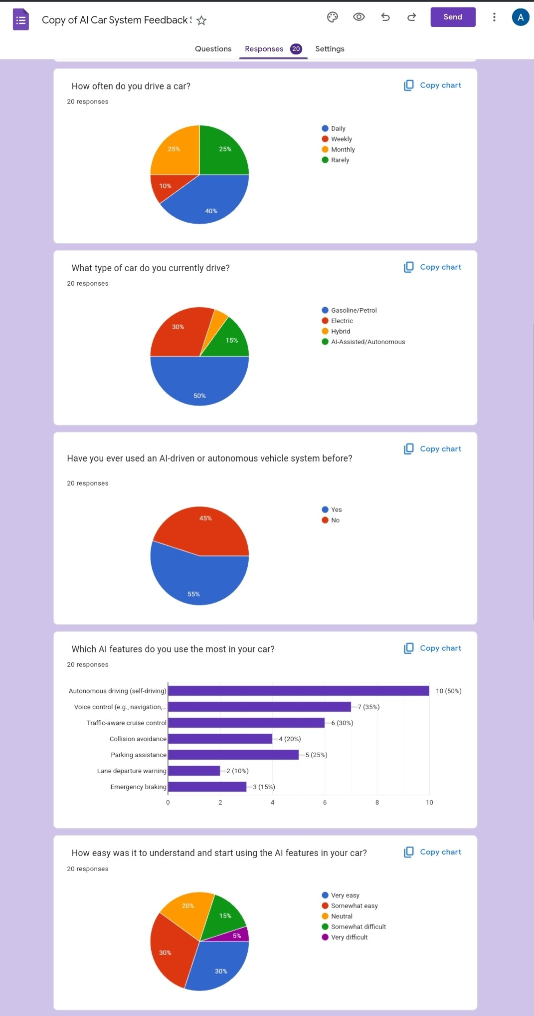

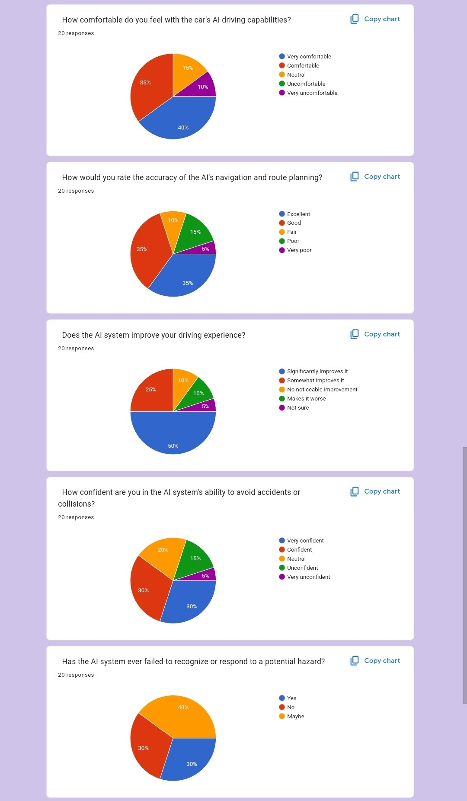

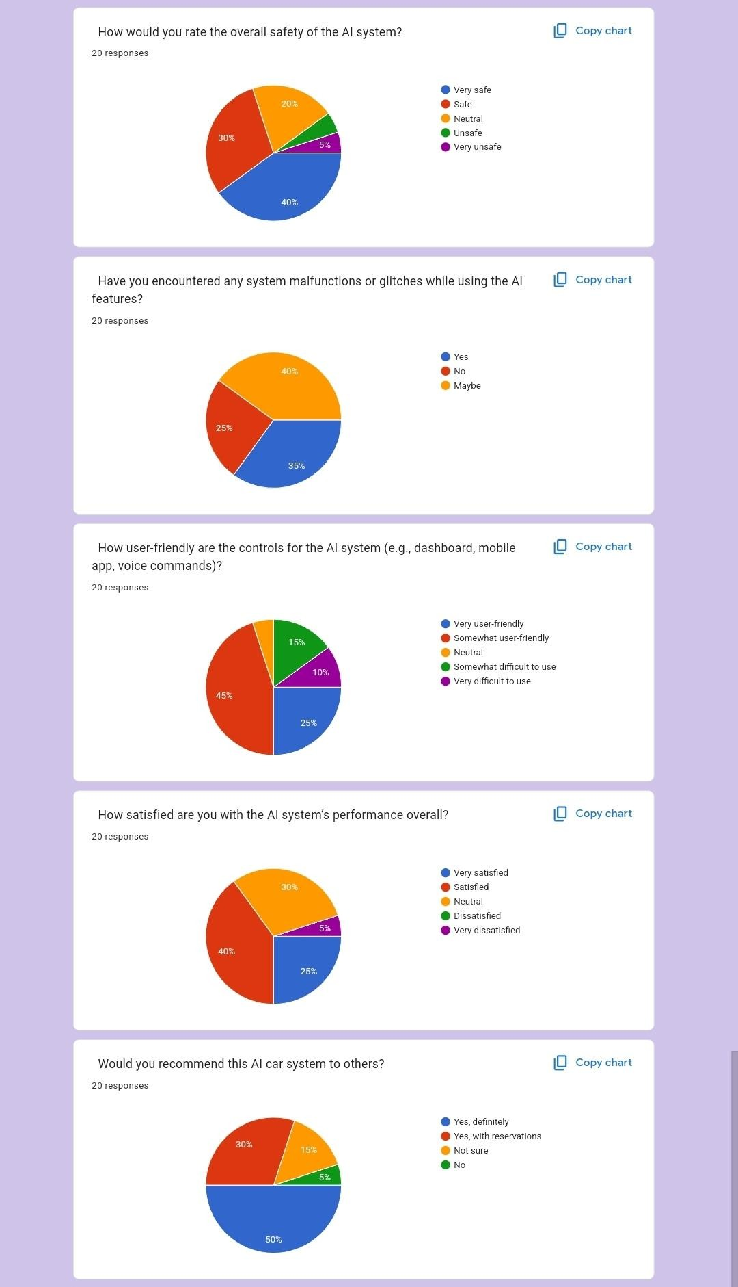

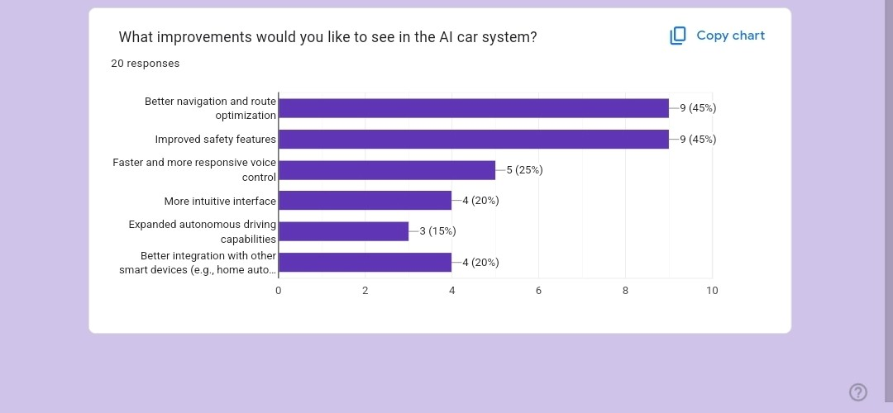

**Wireflow :**

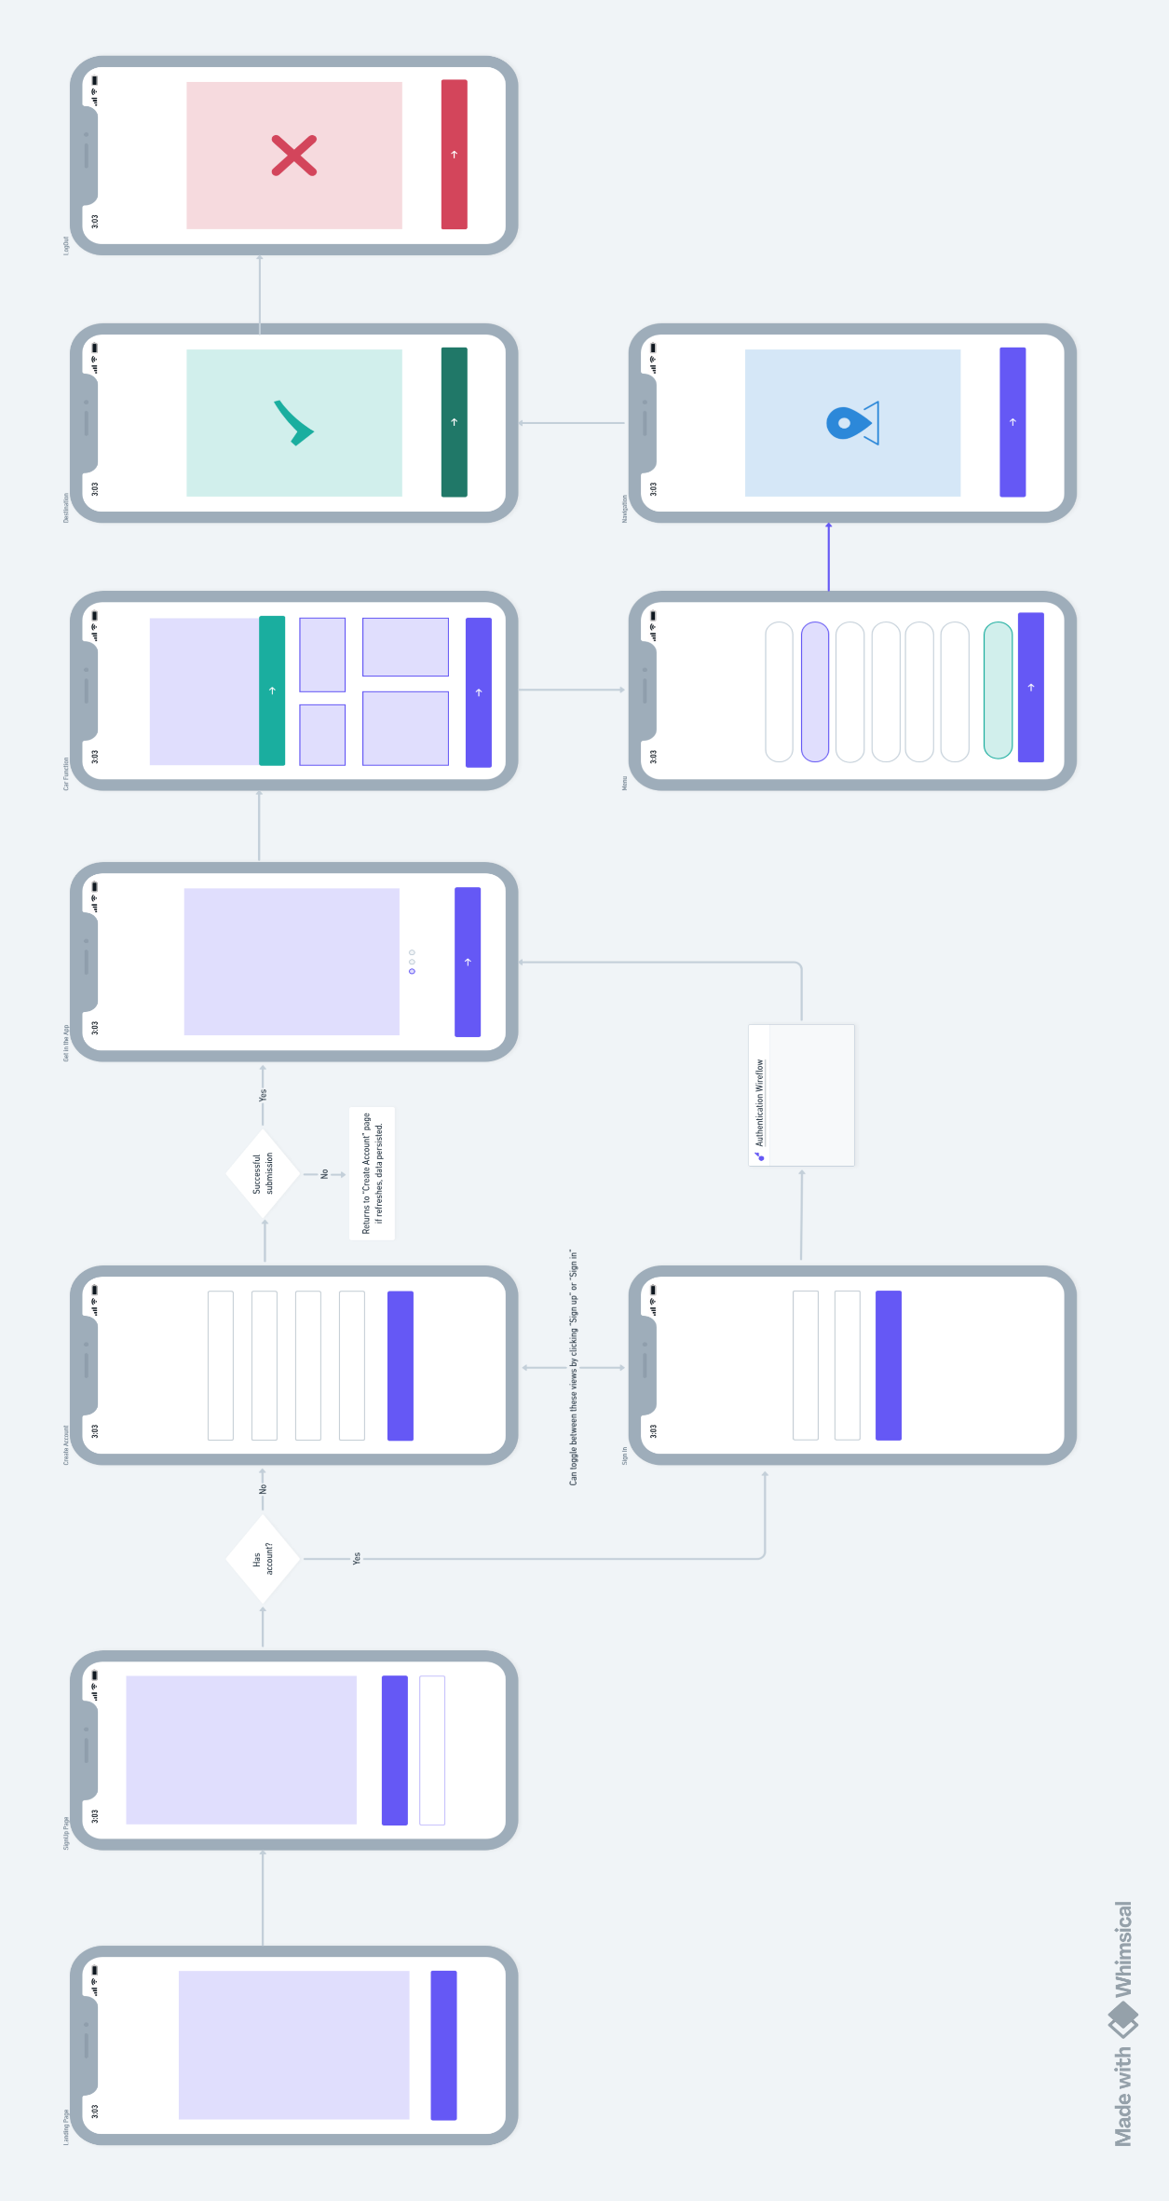

**Mood Board:**

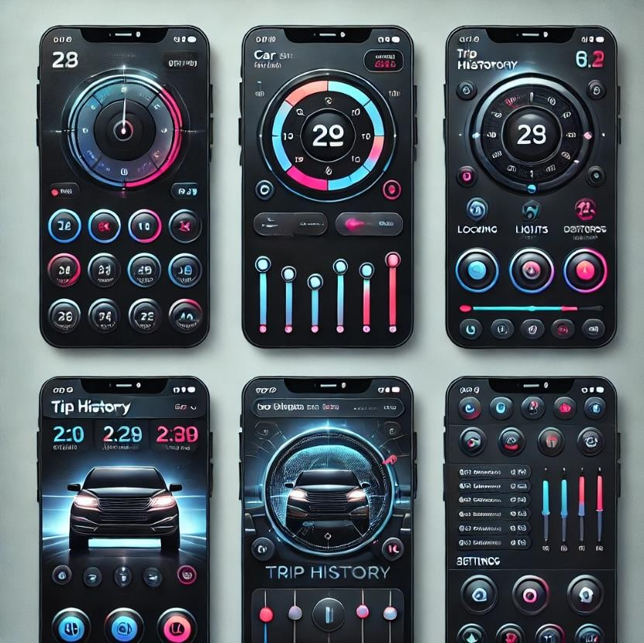

**Art Board :**

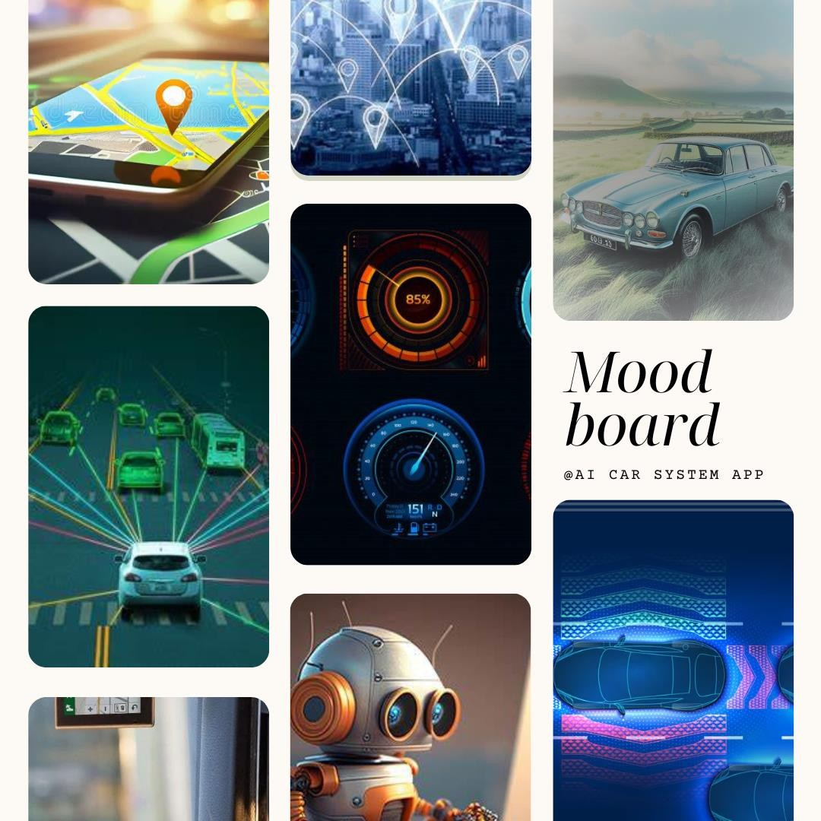

# Color Palette

### Primary Colors

1. **Electric Blue**: #007BFF (for key buttons and highlights)
2. **Bright Red**: #FF4D4D (for alerts or critical actions)
3. **Vivid Green**: #28A745 (for positive indicators like success states)

### Secondary Colors

1. **Amber Yellow**: #FFC107 (to indicate warnings or highlight lesser-important actions)
2. **Aqua Cyan**: #17A2B8 (for informational elements or secondary buttons)
3. **Soft Purple**: #6F42C1 (for decorative or optional accents)

### Neutral Colors

1. **Dark Gray**: #343A40 (for backgrounds and text emphasis)
2. **Light Gray**: #CED4DA (for borders or inactive states)
3. **White**: #FFFFFF (for primary text or background contrast)
4. **Off-Black**: #212529 (for headers or high-contrast areas)

# Typography

1. Segoe UI Semibold
2. Calibri (Body)
3. ALGERIAN
4. Bradley Hand ITC
5. Copperplate Gothic Light
6. Mongolian Baiti
7. Franklin Gothic Medium
8. Rockwell
9. Arial

**Wireframe :**

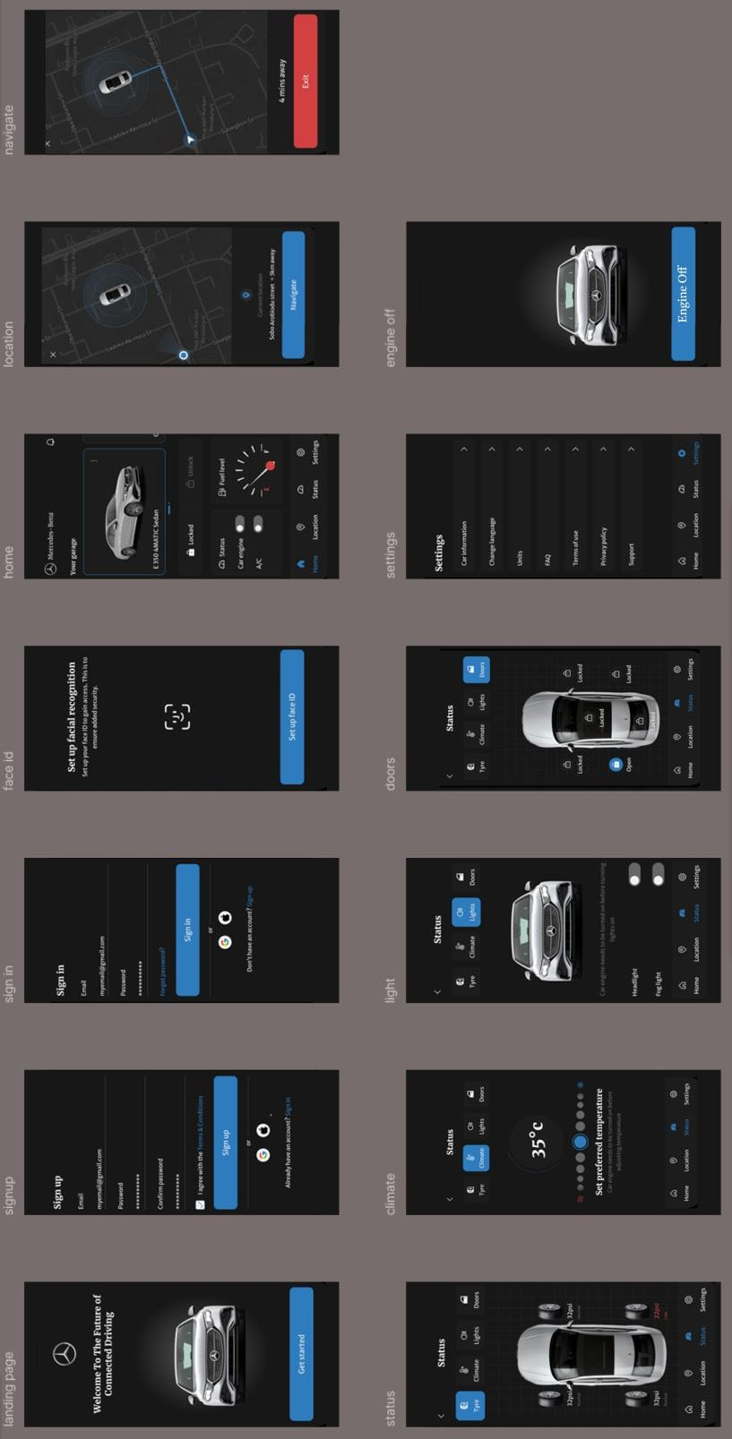

**Prototype :**

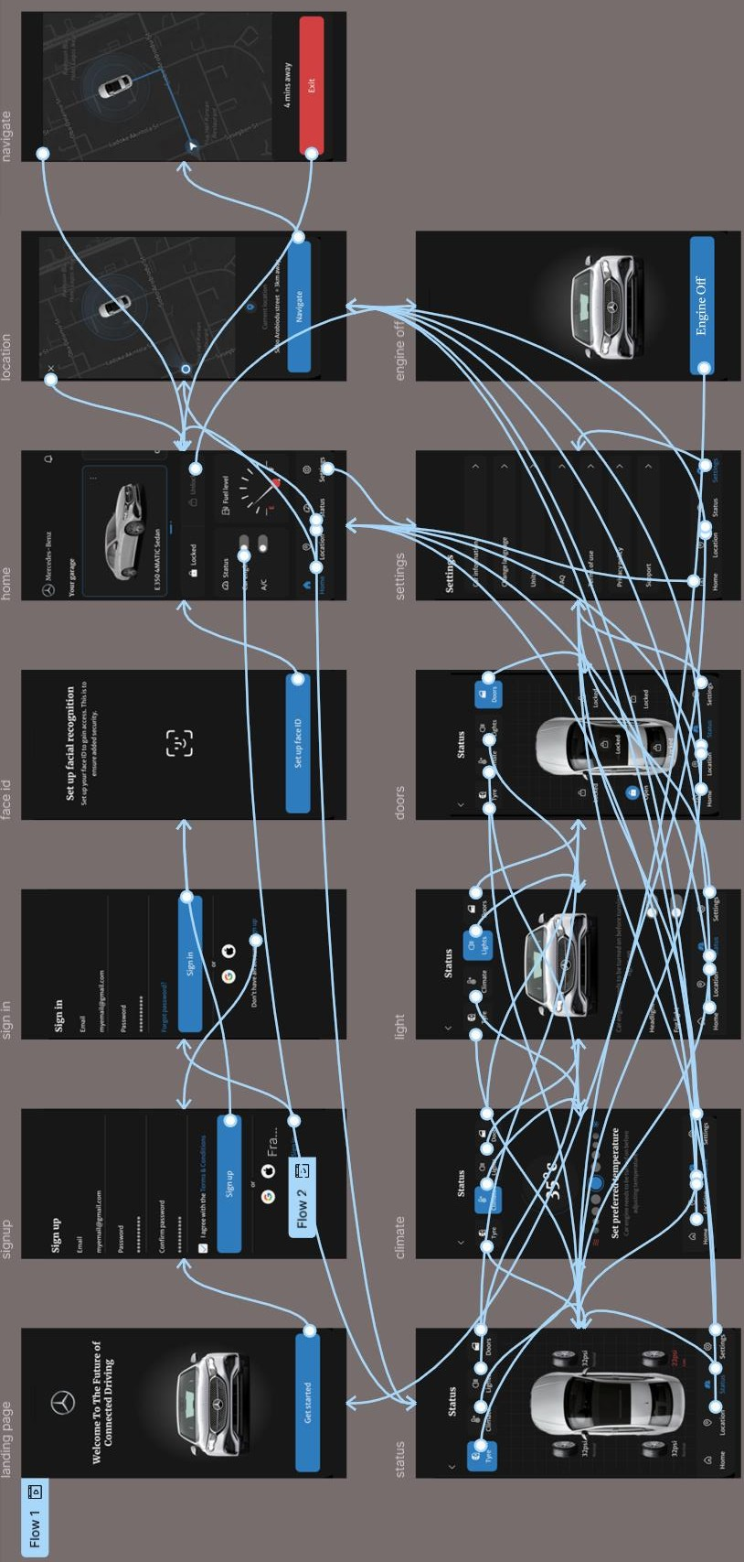

## WalkThrough

<!DOCTYPE html>

<html lang="en">

<head>

<meta charset="UTF-8">

<meta name="viewport" content="width=device-width, initial-scale=1.0">

<title>Walkthrough</title>

</head>

<body>

<div class="Walkthrough" style="width: 1280px; height: 720px; position: relative; background: #CFCFCF">

<div class="Frame1" style="width: 1280px; height: 75px; left: 0px; top: 0px; position: absolute; background: #7C7979">

<div class="ChartCandlestick" style="width: 24px; height: 24px; left: 1237px; top: 26px; position: absolute">

<div class="Vector" style="width: 5px; height: 11px; left: 2.50px; top: 7px; position: absolute; background: black"></div>

<div class="Vector" style="width: 1.50px; height: 6.50px; left: 4.25px; top: 2px; position: absolute; background: black"></div>

<div class="Vector" style="width: 1.50px; height: 5.50px; left: 4.25px; top: 16.50px; position: absolute; background: black"></div>

<div class="Vector" style="width: 5px; height: 9px; left: 9.50px; top: 11px; position: absolute; background: black"></div>

<div class="Vector" style="width: 1.50px; height: 10.50px; left: 11.25px; top: 2px; position: absolute; background: black"></div>

<div class="Vector" style="width: 1.50px; height: 3.50px; left: 11.25px; top: 18.50px; position: absolute; background: black"></div>

<div class="Vector" style="width: 5px; height: 11px; left: 16.50px; top: 4px; position: absolute; background: black"></div>

<div class="Vector" style="width: 1.50px; height: 3.50px; left: 18.25px; top: 2px; position: absolute; background: black"></div>

<div class="Vector" style="width: 1.50px; height: 8.50px; left: 18.25px; top: 13.50px; position: absolute; background: black"></div>

</div>

<div class="SlackNeedYourPermissionToEnableDesktopNotification" style="width: 608px; height: 42px; left: 336px; top:

20px; position: absolute; color: black; font-size: 24px; font-family: Alatsi; font-weight: 400; word-wrap: break-word">Slack need your permission to enable desktop notification.</div>

</div>

<div class="WelcomeTo" style="width: 414px; height: 58px; left: 516px; top: 169px; position: absolute; color: #A45E5E; font- size: 64px; font-family: Aclonica; font-weight: 400; word-wrap: break-word">Welcome To</div>

<div class="AiCarSystem" style="width: 656px; height: 160px; left: 312px; top: 236px; position: absolute; color: #414141; font-size: 128px; font-family: East Sea Dokdo; font-weight: 400; word-wrap: break-word">AI CAR SYSTEM</div>

<img class="AiCarSystemLogoCopy1" style="width: 241px; height: 227px; left: 275px; top: 75px; position: absolute" src="https://via.placeholder.com/241x227" />

<div

class="ArtificialIntelligenceAiIsTransformingTheAutomotiveIndustryInVariousWaysFromAutonomousDrivingToManufacturingProc essesHereAreAFewKeyAreasWhereAiIsMakingASignificantImpactAutonomousVehiclesManufacturingSafetyFeaturesPredictiveMa

intenanceFuelEfficiency" style="width: 1040px; height: 153px; left: 120px; top: 409px; position: absolute; color: black; font-size: 24px; font-family: Aboreto; font-weight: 400; word-wrap: break-word">Artificial Intelligence (AI) is transforming the automotive industry in various ways, from autonomous driving to manufacturing processes. Here are a few key areas where AI is making a significant impact:<br/>*Autonomous Vehicles,Manufacturing,Safety Features,Predictive Maintenance, Fuel Efficiency:</div>

<div class="MessageDots" style="width: 86px; height: 61px; left: 597px; top: 562px; position: absolute">

<div class="Vector" style="width: 24px; height: 17px; left: 8px; top: 17px; position: absolute; background: black"></div>

<div class="Vector" style="width: 12.54px; height: 8.90px; left: 36.73px; top: 21.60px; position: absolute; background: black"></div>

<div class="Vector" style="width: 12.54px; height: 8.90px; left: 53.75px; top: 21.60px; position: absolute; background: black"></div>

</div>

<div class="Frame2" style="width: 244px; height: 51px; left: 516px; top: 636px; position: absolute; background: #087EB9; border-radius: 10px; overflow: hidden">

<div class="Continue" style="width: 111px; height: 27px; left: 67px; top: 12px; position: absolute; color: white; font-size: 24px; font-family: Alatsi; font-weight: 400; word-wrap: break-word">Continue...</div>

</div>

</div>

</body>

</html>

## Registeration

<!DOCTYPE html>

<html lang="en">

<head>

<meta charset="UTF-8">

<meta name="viewport" content="width=device-width, initial-scale=1.0">

<title>Registeration</title>

</head>

<body>

<div class="Registeration" style="width: 1280px; height: 720px; position: relative; background: #7C7979">

<div class="Frame3" style="width: 338px; height: 338px; padding: 70px; left: 34px; top: 142px; position: absolute; background: #A9A4A4; justify-content: center; align-items: center; display: inline-flex">

<img class="Letter" style="width: 198px; height: 198px; box-shadow: 4px 4px 4px; filter: blur(4px)" src="https://via.placeholder.com/198x198" />

</div>

<div class="Rectangle1" style="width: 330px; height: 55px; left: 414px; top: 171px; position: absolute; background: #D9D9D9"></div>

<div class="Rectangle9" style="width: 330px; height: 55px; left: 791px; top: 171px; position: absolute; background: #D9D9D9"></div>

<div class="Rectangle2" style="width: 330px; height: 55px; left: 414px; top: 305px; position: absolute; background: #D9D9D9"></div>

<div class="Rectangle10" style="width: 330px; height: 55px; left: 791px; top: 305px; position: absolute; background: #D9D9D9"></div>

<div class="Rectangle3" style="width: 325px; height: 55px; left: 419px; top: 425px; position: absolute; background: #D9D9D9"></div>

<div class="Rectangle11" style="width: 108px; height: 55px; left: 796px; top: 425px; position: absolute; background: #D9D9D9"></div>

<div class="Rectangle12" style="width: 108px; height: 55px; left: 909px; top: 425px; position: absolute; background: #D9D9D9"></div>

<div class="Rectangle13" style="width: 99px; height: 55px; left: 1022px; top: 425px; position: absolute; background: #D9D9D9"></div>

<div class="Rectangle7" style="width: 1080px; height: 88px; left: 78px; top: 592px; position: absolute; background: #D9D9D9"></div>

<div class="Rectangle8" style="width: 236px; height: 46px; left: 884px; top: 613px; position: absolute"></div>

<div class="Frame4" style="width: 225px; height: 52px; padding-top: 16px; padding-bottom: 15px; padding-left: 21px; padding-right: 21px; left: 907px; top: 607px; position: absolute; background: #087EB9; border-radius: 10px; overflow: hidden; justify-content: center; align-items: center; display: inline-flex">

<div class="CreateAccount" style="width: 183px; height: 21px; color: white; font-size: 20px; font-family: Almarai; font- weight: 400; word-wrap: break-word">CREATE ACCOUNT</div>

</div>

<div class="JoinWithYourPhoneAndEmailAddress" style="width: 1000px; height: 47px; left: 148px; top: 36px; position:

absolute; color: white; font-size: 48px; font-family: Aldrich; font-weight: 400; word-wrap: break-word">Join With Your Phone and Email Address</div>

<div class="UserName" style="width: 134px; height: 21px; left: 414px; top: 142px; position: absolute; text-align: center; color: white; font-size: 20px; font-family: Almarai; font-weight: 400; word-wrap: break-word">USER NAME</div>

<div class="Password" style="width: 134px; height: 21px; left: 791px; top: 142px; position: absolute; text-align: center; color: white; font-size: 20px; font-family: Almarai; font-weight: 400; word-wrap: break-word">PASSWORD</div>

<div class="Email" style="width: 90px; height: 21px; left: 409px; top: 404px; position: absolute; text-align: center; color: white; font-size: 20px; font-family: Almarai; font-weight: 400; word-wrap: break-word">EMAIL</div>

<div class="DateOifBirth" style="width: 170px; height: 21px; left: 791px; top: 397px; position: absolute; text-align: center; color: white; font-size: 20px; font-family: Almarai; font-weight: 400; word-wrap: break-word">DATE OIF BIRTH</div>

<div class="Phone" style="width: 110px; height: 21px; left: 404px; top: 278px; position: absolute; text-align: center; color: white; font-size: 20px; font-family: Almarai; font-weight: 400; word-wrap: break-word">PHONE</div>

<div class="Otp" style="width: 110px; height: 21px; left: 776px; top: 275px; position: absolute; text-align: center; color: white; font-size: 20px; font-family: Almarai; font-weight: 400; word-wrap: break-word">OTP</div>

<div class="Dd" style="width: 66px; height: 38px; left: 800px; top: 442px; position: absolute; text-align: center; color: #5E5555; font-size: 20px; font-family: Almarai; font-weight: 400; word-wrap: break-word">DD</div>

<div class="Mm" style="width: 66px; height: 38px; left: 904px; top: 443px; position: absolute; text-align: center; color: #675555; font-size: 20px; font-family: Almarai; font-weight: 400; word-wrap: break-word">MM</div>

<div class="Yyyy" style="width: 66px; height: 38px; left: 1022px; top: 444px; position: absolute; text-align: center; color: #4B3636; font-size: 20px; font-family: Almarai; font-weight: 400; word-wrap: break-word">YYYY</div>

<div class="Rectangle14" style="width: 26px; height: 26px; left: 104px; top: 623px; position: absolute; background: white; border: 1px black solid"></div>

<div class="IAcknoledgeThatIHaveReadAndAcceptTheTermsOfUserAgreementAndConsentToThePrivacyPolicy" style="width: 730px; height: 43px; left: 149px; top: 616px; position: absolute"><span style="color: black; font-size: 20px; font-family: Almarai; font-weight: 400; word-wrap: break-word">I Acknoledge that I have Read and Accept the </span><span style="color: #087EB9; font-size: 20px; font-family: Almarai; font-weight: 400; word-wrap: break-word">TERMS OF USER AGREEMENT </span><span

style="color: black; font-size: 20px; font-family: Almarai; font-weight: 400; word-wrap: break-word">and Consent to the

</span><span style="color: #087EB9; font-size: 20px; font-family: Almarai; font-weight: 400; word-wrap: break-word">PRIVACY POLICY.</span></div>

</div>

</body>

</html>

## Captcha

<!DOCTYPE html>

<html lang="en">

<head>

<meta charset="UTF-8">

<meta name="viewport" content="width=device-width, initial-scale=1.0">

<title>Capcha</title>

</head>

<body>

<div class="Capcha" style="width: 984px; height: 975px; position: relative; background: #A6A6A6">

<div class="SignInWithYour" style="width: 223px; height: 43px; left: 383px; top: 33px; position: absolute; color: black; font- size: 32px; font-family: Advent Pro; font-weight: 700; word-wrap: break-word">Sign in with your</div>

<div class="Group" style="width: 198px; height: 74.51px; left: 272px; top: 107.81px; position: absolute">

<div class="Vector" style="width: 47.55px; height: 58.25px; left: 0px; top: 0px; position: absolute; background: #4285F4"></div>

<div class="Vector" style="width: 31.70px; height: 37.59px; left: 51.52px; top: 19.98px; position: absolute; background: #EA4335"></div>

<div class="Vector" style="width: 30.15px; height: 54.53px; left: 121.43px; top: 19.98px; position: absolute; background: #4285F4"></div>

<div class="Vector" style="width: 31.70px; height: 37.59px; left: 86.76px; top: 19.98px; position: absolute; background: #FBBC05"></div>

<div class="Vector" style="width: 6.79px; height: 56.90px; left: 156.81px; top: 0.85px; position: absolute; background: #34A853"></div>

<div class="Vector" style="width: 29.01px; height: 37.59px; left: 168.99px; top: 19.98px; position: absolute; background: #EA4335"></div>

</div>

<div class="Account" style="width: 189px; height: 71px; left: 487px; top: 102px; position: absolute; color: black; font-size: 64px; font-family: Advent Pro; font-weight: 700; word-wrap: break-word">Account</div>

<div class="Rectangle27" style="width: 243px; height: 47px; left: 371px; top: 219px; position: absolute; background: #D9D9D9"></div>

<div class="Rectangle28" style="width: 243px; height: 47px; left: 371px; top: 281px; position: absolute; background: #D9D9D9"></div>

<div class="Rectangle30" style="width: 243px; height: 47px; left: 366px; top: 633px; position: absolute; background: #D9D9D9"></div>

<div class="Rectangle31" style="width: 143px; height: 47px; left: 429px; top: 780px; position: absolute; background: #4285F4; border-radius: 20px"></div>

<div class="Rectangle29" style="width: 305px; height: 111px; left: 366px; top: 439px; position: absolute; background: #D9D9D9"></div>

<div class="EnterTheCorrectPasswordAboveAndThenTypeTheCharactersYouSeeInThePicture" style="width: 470px; height: 57px; left: 371px; top: 355px; position: absolute; color: black; font-size: 24px; font-family: Advent Pro; font-weight: 700; word- wrap: break-word">Enter the correct Password above and then type the characters you see in the picture</div>

<div class="LettersAreNotCaseSensitiveRememberMeOnTjisComputer" style="width: 324px; height: 57px; left: 366px; top: 701px; position: absolute; color: black; font-size: 24px; font-family: Advent Pro; font-weight: 700; word-wrap: break- word">Letters are not Case-sensitive<br/>Remember me on tjis computer.</div>

<div class="TypeTheWordAbove" style="width: 205px; height: 34px; left: 366px; top: 578px; position: absolute; color: black; font-size: 24px; font-family: Advent Pro; font-weight: 700; word-wrap: break-word">Type the word above :</div>

<div class="ICannotAccessMyAccount" style="width: 294px; height: 34px; left: 366px; top: 852px; position: absolute; color: #087EB9; font-size: 24px; font-family: Advent Pro; font-weight: 700; word-wrap: break-word">I CANNOT ACCESS MY ACCOUNT</div>

<div class="Email" style="width: 84px; height: 34px; left: 282px; top: 229px; position: absolute; color: black; font-size: 24px; font-family: Advent Pro; font-weight: 700; word-wrap: break-word">EMAIL :</div>

<div class="Password" style="width: 130px; height: 34px; left: 230px; top: 291px; position: absolute; color: black; font-size: 24px; font-family: Advent Pro; font-weight: 700; word-wrap: break-word">PASSWORD :</div>

<img class="Capcha1" style="width: 267px; height: 62px; left: 385px; top: 463px; position: absolute" src="https://via.placeholder.com/267x62" />

<div class="Rectangle32" style="width: 30px; height: 30px; left: 323px; top: 643px; position: absolute; background: #D9D9D9"></div>

<div class="SignIn" style="width: 95px; height: 48px; left: 456px; top: 782px; position: absolute; color: white; font-size: 32px; font-family: Advent Pro; font-weight: 700; word-wrap: break-word">Sign in</div>

<div class="Line4" style="width: 294.01px; height: 0px; left: 361px; top: 884px; position: absolute; border: 1px #087EB9 solid"></div>

<img class="Refresh" style="width: 39px; height: 39px; left: 623px; top: 637px; position: absolute" src="https://via.placeholder.com/39x39" />

<img class="Refresh" style="width: 39px; height: 39px; left: 676px; top: 634px; position: absolute" src="https://via.placeholder.com/39x39" />

<img class="Verify" style="width: 33px; height: 33px; left: 325px; top: 640px; position: absolute" src="https://via.placeholder.com/33x33" />

</div>

</body>

</html>